Larsen & Toubro Infotech.

Financial Statement and Ratio Analysis

-by

Shivam Agarwal 2020123 [shivam20123@iiitd.ac.in](mailto:shivam20123@iiitd.ac.in)

Aurko Mitra MT21166 [aurko21166@iiitd.ac.in](mailto:aurko21166@iiitd.ac.in)

**Table of Contents**

1. **Introduction**
2. **Financial Statement** 
   1. **Balance Sheet Overview 2018-2022**
   2. **Income Statement Overview 2018-2022**
3. **Financial Analysis**
   1. **Horizontal Analysis**
      1. **Analysis of Balance Sheet**
      2. **Analysis of Income Statement**
   2. **Ratio Analysis**
      1. **Liquidity Ratio**
      2. **Solvency Ratio**
      3. **Turnover Ratio**
      4. **Profitability Ratio**
4. **Conclusion**
5. **Doing a SIP in LTI**
6. **Annexures**

**Introduction**

Larsen and Toubro Infotech Ltd.(LTI) was established in 1996 as a subsidiary of Larsen and Toubro Group which has operations in many fields like engineering, construction, manufacturing, technology, information technology and financial services.

LTI is ranked as the sixth largest Indian IT services company in terms of exports and is among the top 15 IT service providers globally. It offers information technology, software and services with a focus on manufacturing, BFSI and communications and embedded systems. It also provides services for embedded intelligence and engineering.

LTI is functioning in 33 countries worldwide with software development centers and 44 sales offices. It has over 50 clients in the Fortune 500 list. The company has acquired several businesses worldwide and currently has 13 subsidiaries with the most recent merger with Mindtree making it India’s 5th largest IT service provider.

Some News about the company in the current year:

* Partnering with Securonix and Snowflake to strengthen their Cybersecurity Offerings
* Partnering with IIT Madras to innovate in 5G space
* LTI’s Brand Value crosses $1 Billion
* Opening of new Engagement Center, Innovation Lab and ServiceNow Experience Center in Hartford, CT, USA
* Achieves Premier Partner Status in the AWS Partner Network
* Strengthen strategic collaboration with Microsoft and Google Cloud
* LTI and Mindtree start operations as a merged entity(since 14 Nov)

| Founded | December 1996 |
| --- | --- |
| Headquarters | Mumbai, India |
| Key People | A.M.Naik(Non-Executive Chairman)  S.N.Subrahmanyan (Non-Executive Vice Chairman) |
| Industry | Information Technology, Outsourcing, Consultancy |
| Revenue | Rs. 12,644 crore |
| Net Income | Rs. 1,938 crore |
| Employees | around 46,000 |
| Website | [https://www.lntinfotech.com](https://www.lntinfotech.com/) |

**2. Financial Statement**

We have done our analysis on LTI using its Balance Sheet and Income Statements for the last 5 years (i.e 2018, 2019, 2020, 2021, 2022), which are shown below

**2.1 Balance Sheet Overview**

A balance sheet has 3 parts: Assets, Liabilities and Total Equity where :

Total Assets = Total Liabilities + Total Equity

In this section we will go over the assets, equity and liabilities of the company over the last 5 years.

**2.1.1 Assets**

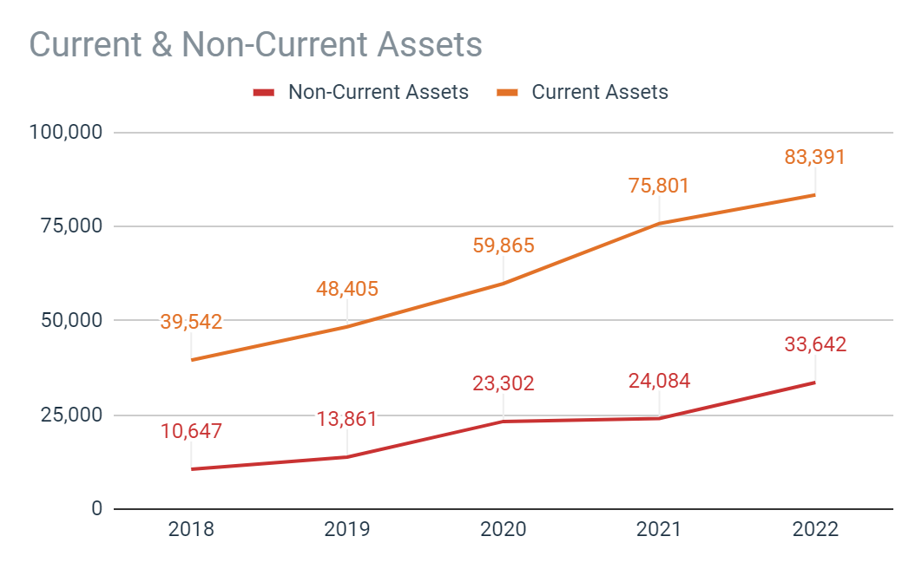

From this we can see that the company has had a very good increase in its assets over the last 5 years.

Most of the company’s assets are current assets with little in terms of PP&M as IT service providers companies have a low investment requirement in this as compared to, say, manufacturing companies who need a lot of land, raw materials and machines to produce output.

**2.1.2 Equity**

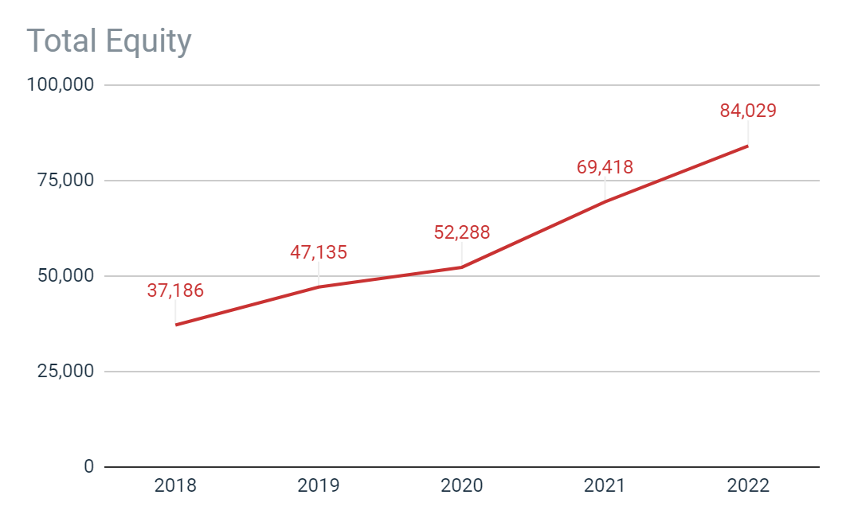

We can see that the company has had a good increase in its equity over the years.

From the balance sheet we can also see that the company is almost debt free which shows that the investors will have a lower risk on their investments and higher dividend yield in the stock. Company’s equity has grown at a rate of around 23 percent over the years.

**2.1.3 Liabilities**

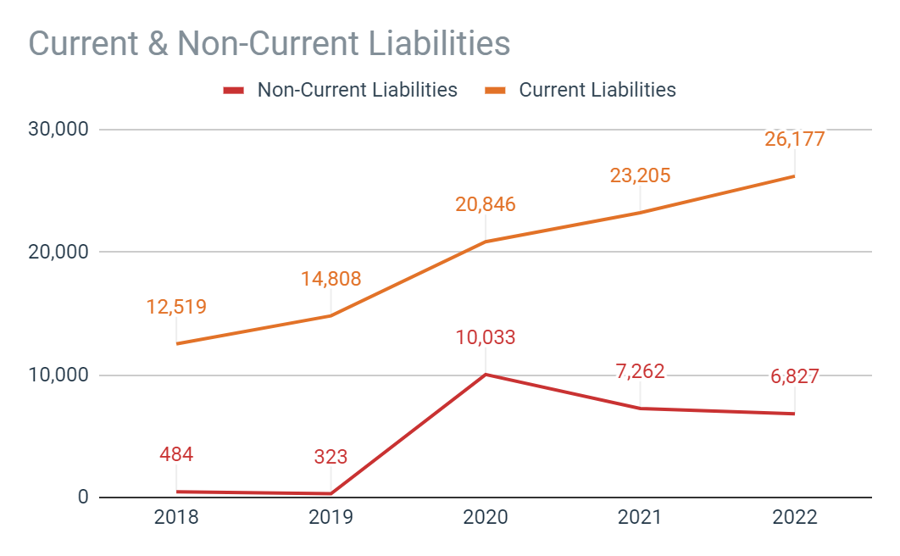

From this we can see that the majority of the company's liabilities are current liabilities. There has been growth in the company's liabilities over the last 5 years but it is quite low as compared to the growth rate of assets or equity.

**2.2 Income Statement**

An Income statement shows the revenue that the company is generating over a period and where it is spending its money and by how much (including the depreciation and amortization of various assets). It also includes the tax paid during that period.

The purpose of an income statement is to let the investors know whether the company is making or losing money from its daily operations.

**2.2.1 Total Revenue**

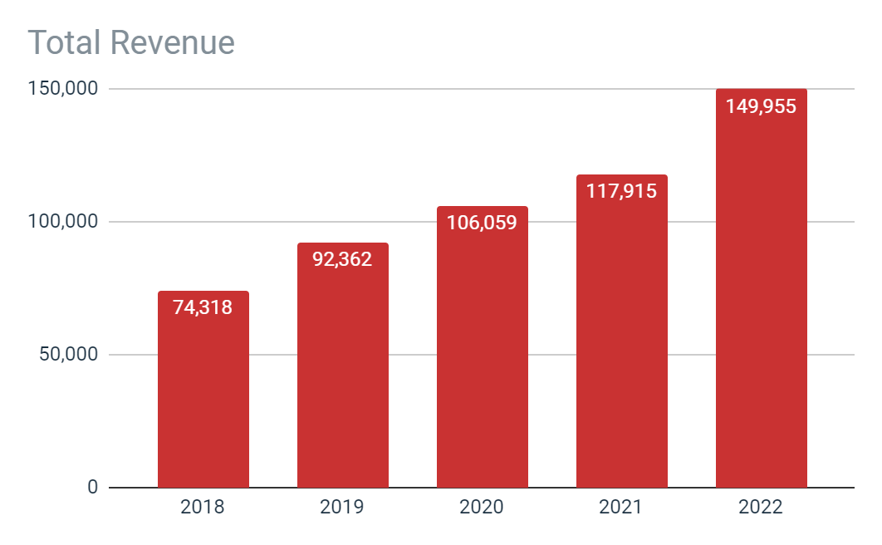

From this graph, we can see that the company has had a good yearly increase in its revenue over the years which is around 19% from 2018 to 2022

**2.2.1 Total Expenses**

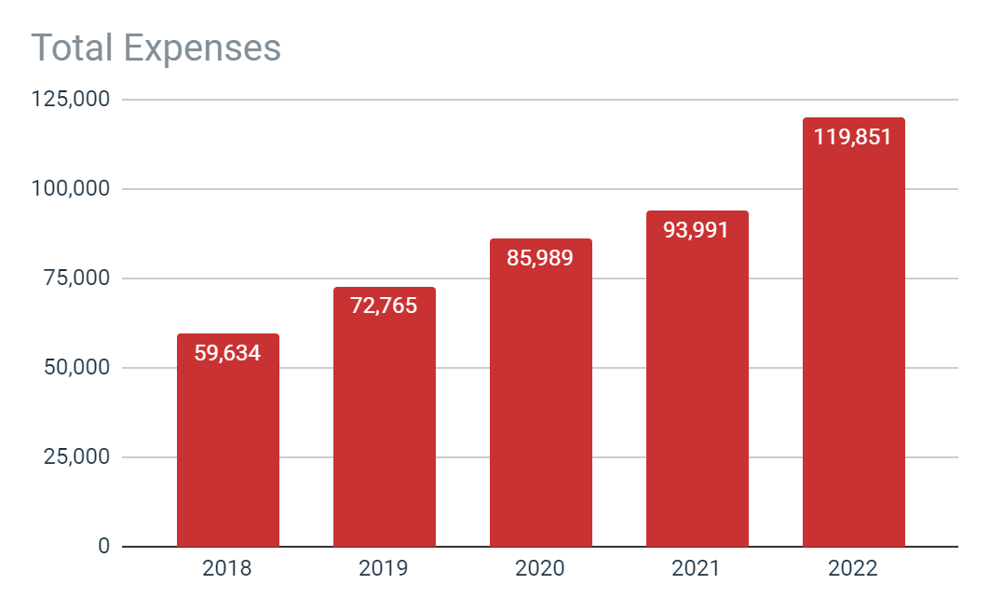

The expenses of the company have seen a similar growth over the years like the revenue which is explained by the almost constant net income margin of the company over the years(given later in the report)

**2.2.3 Net Income**

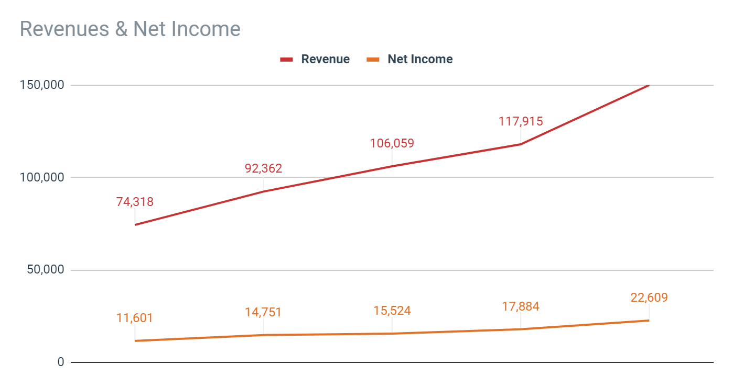

we can see that the company has had a good increase in its net income after tax over the years which is around 17 %

**3 Financial Analysis**

Financial Analysis is done to find out how the company is doing as compared to previous years or other companies in the same sector as it removes the factor of base size of the company since this analysis is done in ratios.

We will be looking at the 2 major types of analysis :

1. Horizontal Analysis
2. Ratio Analysis

**3.1 Horizontal Analysis**

It refers to taking several years of financial data and comparing them to each other to determine the growth rate. This allows the analyst to identify whether the company is growing or declining and to identify important trends.

**3.1.1 Horizontal Analysis of Current Assets and Noncurrent Assets**

From this we can see that the company’s asset allocation is shifting towards the current assets which means that the company is more liquid but it can also mean that the company is not investing/looking more towards long term growth.

**3.1.2 Horizontal Analysis of Current liabilities and Noncurrent liabilities**

We can see that the company has seen a major growth in their non current liabilities which is caused by lease liabilities

**3.1.3 Horizontal Analysis of Equity**

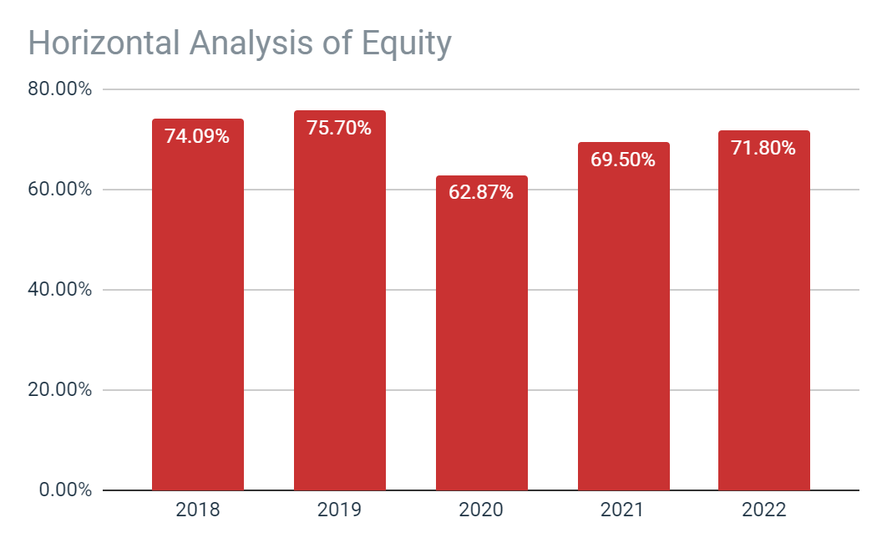

We can see that the most assets are owned by the shareholders of the company as compared to using debt. It is a good thing as it shows that a large number of investors want to invest in the company.

3.2 Ratio Analysis

* Liquidity
* Solvency
* Profitability

3.2.1 Liquidity Ratio Analysis

It assesses the ability of a company to remain liquid. It measures the cash ‘cushion’ a business has for an accounting period.

We are using the following ratios for liquidity analysis

* Current Ratio
* Net Working Capital

**3.2.1.1 Current Ratio**

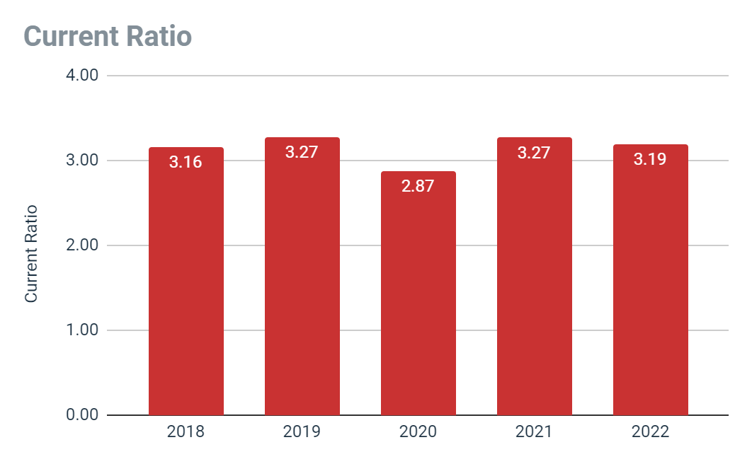

Current Ratio= Current Assets/ Current Liabilities

The company has maintained a current ratio of around 3.1 to 3.2 over the last 5 years which is a good sign for the liquidity of the company as this shows that the company would not have any trouble to pay off their current liabilities over the next year.

**3.2.1.2 Net Working Capital**

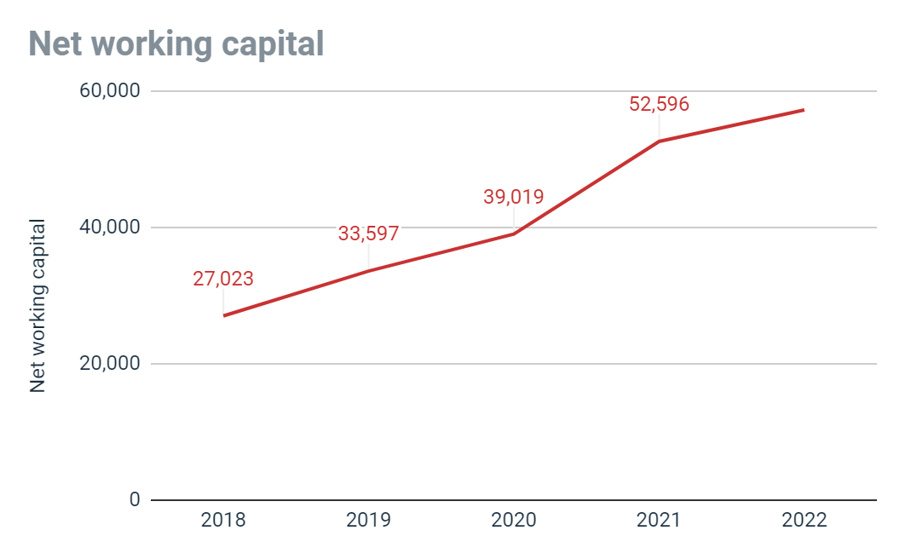

The Company has pretty high net working capital which shows that it shouldn't have any problems in running it day to day operations.

**3.2.2 Solvency Ratio Analysis**

Solvency ratios show a company’s ability to make payments and pay off its long-term obligations to creditors, bondholders, and banks. A higher solvency ratio indicates that the company is more creditworthy.

We won't be using debt ratios for this analysis as LTI is almost debt free.

**3.2.2.1 Equity Ratio**

Equity ratios show what percentage of the company’s total assets are owned by the shareholders and how much is financed by the creditors.

Equity ratio = Total Equity / Total Assets

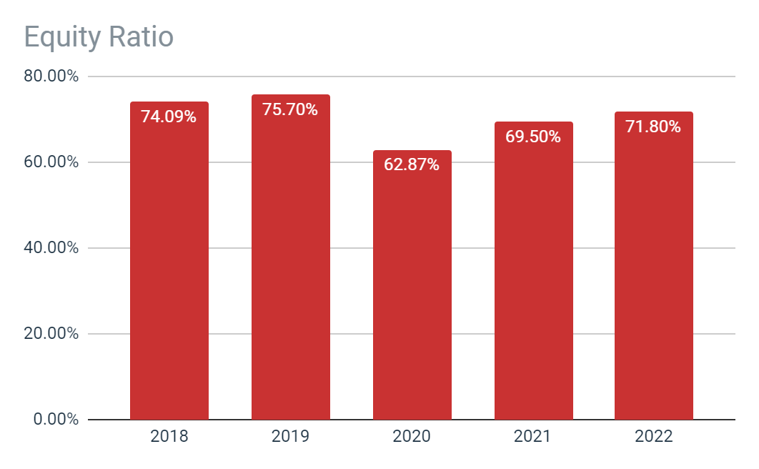

Since being debt free, LTI has a very high equity ratio. A high equity ratio shows that the company is good for investment since so many people are willing to invest in the company.

**3.2.3 Profitability Ratios**

They are used to assess a company’s ability to make profits given the investments made in assets or equity

It measures how well the company’s management has used the funds to generate a profit

We will be looking at the following ratios for Profitability Analysis:

* Net Profit Margin
* Return on Total Assets
* Return on Common Equity

**3.2.3.1 Net Profit Margin**

This ratio is used to measure the amount of net income earned per unit of revenue by the company. A higher net profit margin is desirable as it shows how effectively a company converts sales to net profit.

Net Profit Margin = Net Profit / Total Revenue

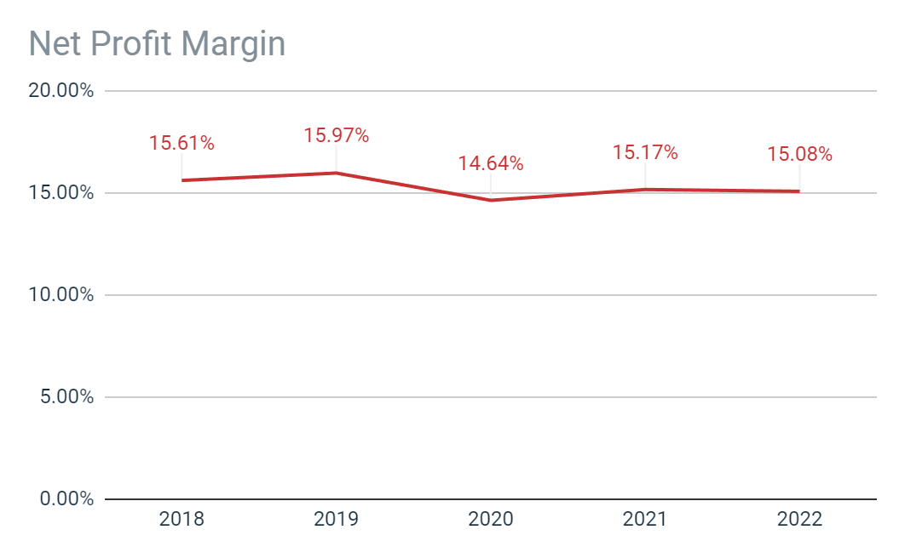

The Company has had a near constant profit margin over the last 5 years which shows that company has been in a constant price competition with other companies of this sector since they cant raise their prices and it also shows that most of the company’s growth has been coming from expansion in new areas or getting more clients with the same services.

**3.2.3.2 Return on Total Assets**

This ratio is used to measure the amount of net income earned per unit of assets by the company. A higher Return on Total Assets is desirable as it shows how effectively a company can use its assets to generate net income.

Return on Total Assets = Net Profit / Total Assets

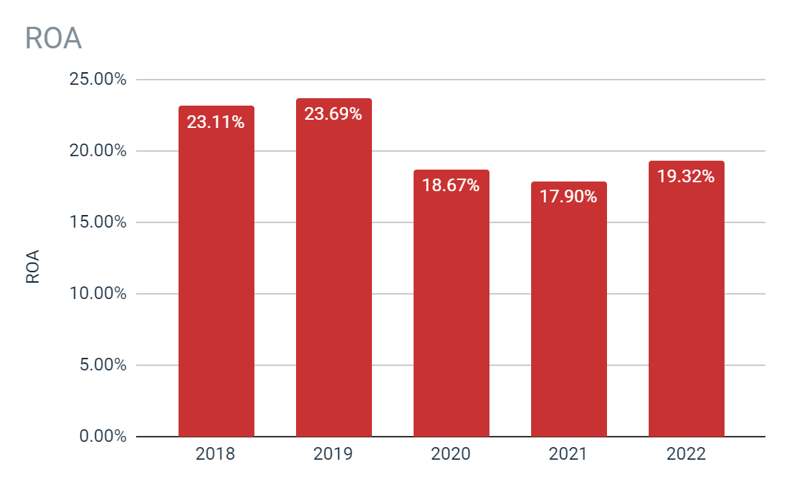

ROA is also used to compare companies in the same industry. ROA of around 19% is similar to some of their competitors like Infosys, but much lower than average 30% ROA of TCS

**3.2.3.3 Return on Equity**

This ratio is used to measure the amount of net income earned per unit of investment by the shareholders of the company. A higher Return on Equity is desirable as it shows how effectively a company uses the amount invested by its shareholders to generate profits

Return on Equity= Net Profit / Total Equity

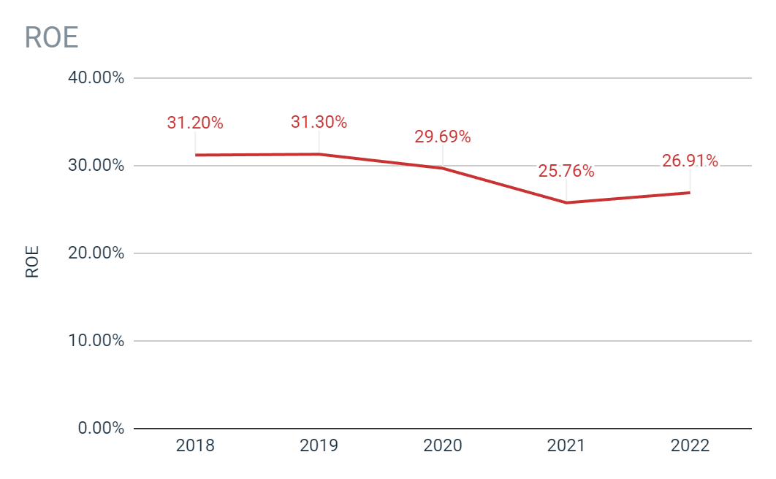

ROE is also used to compare companies in the same industry. ROE of around 27% is lower than some of their competitors like Infosys, and much lower than average ROE of over 40% of TCS

**4 Conclusion**

As we have seen from their balance sheet as well as their income statement, LTI over the last 5 years has seen good growth. Majority of it can be accounted for by their expansion in various countries and the number of their clients over the years. They have acquired several subsidiaries that operate in different countries and with their recent mergers with Mindtree, things look pretty good for the future

Now let's consider some of the problems. LTI’s profitability is much lower than their competitors (near 16% as compared to 20% for Infosys and over 23% for TCS). This shows that they have a tough competition in this field as both Infosys and TCS have a 25% and 40% more Net Profit Margin compared to them. This can also be seen from their Return on Assets and Return on Equity which is lower than the competition.

To sum it up, LTI has had a great growth over the past years but if they don't step up their Profitability and Return on Investment, then they will have a tough time ahead, since the competition will have more money to spend, meaning more money for investments in new fields and R&D which would further increase the gap between them.

**5 Doing a SIP in LTI**

We have invested Rs 10,000 each month on the first trading day for the last 5 years and the dividend received during a month is then added to the amount to be invested in the next month(i.e 10,000).

In a month, we have bought shares up to the first decimal place.

Using this we have bought approx. 275.8 shares of LTI in the last 5 years whose worth as of 1/ Nov/ 2022 would be Rs. 1,308,119.4 .

In 5 years the amount of money invested by us : Rs. 600,000.

Using the above information and the formula for Future Value Interest Factor for Annuity, we can get that the interest rate we have gained on our investments to be about 28% per annum. Which is a pretty high return on investment over the years.

**6 Annexures**

* Financial Statements of the company over the past 5 years
* A combined balance sheet and income statement of the company(common size balance sheet and income statement are given in the same file in the sheet) along with graphs shown in the report as well as the ratios calculated
* A file to record the SIP investment in LTI over the years along with record date and pay dates of its dividend.